**CSDD2002 Emerging Web Technologies**

**Assignment Part: 2**

Name : Dhruv Patel

Student Id: 500225463

**Input:**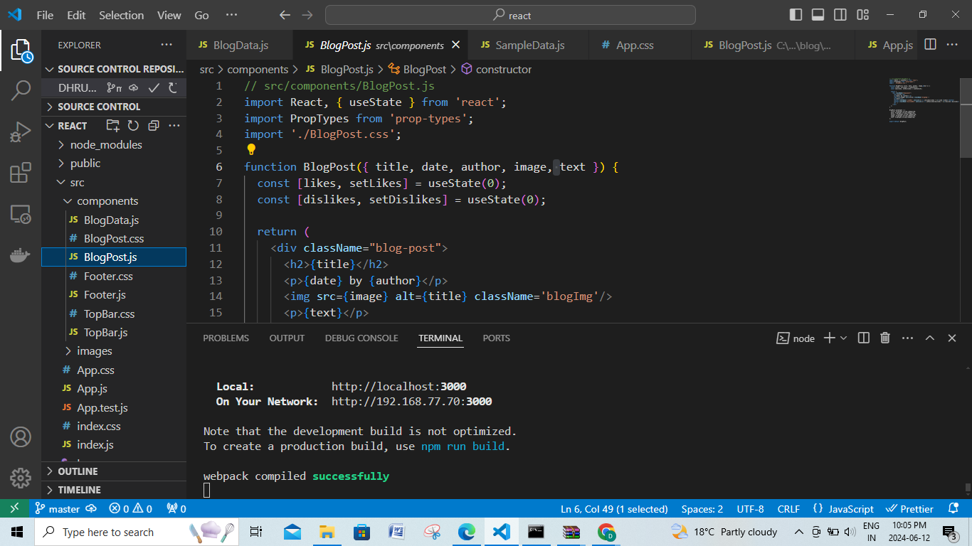

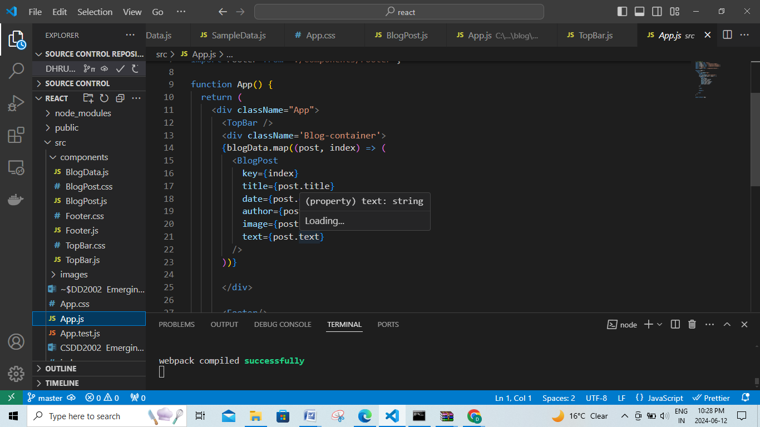

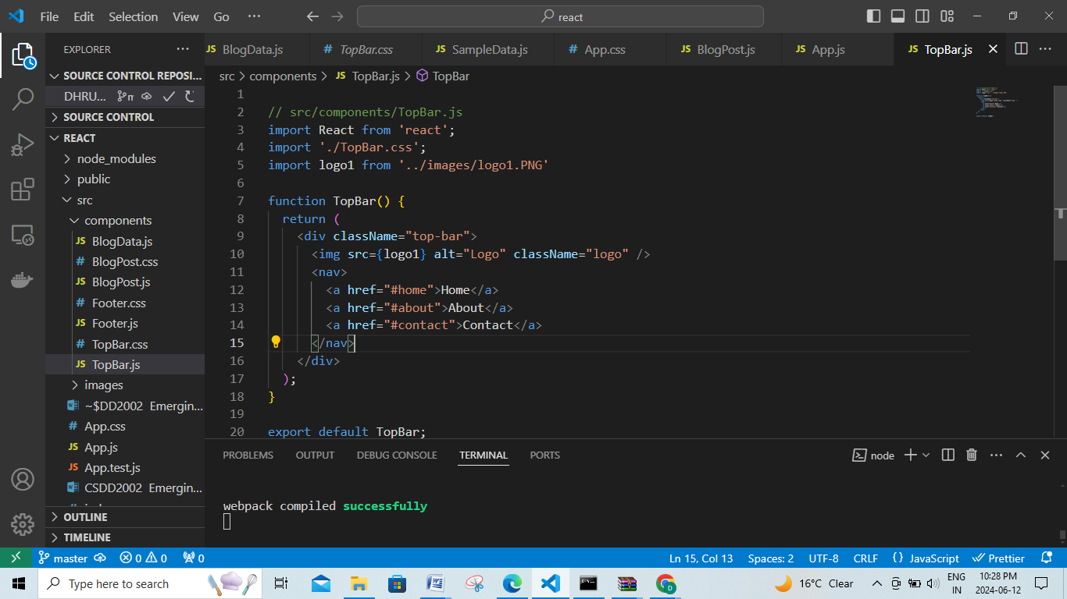

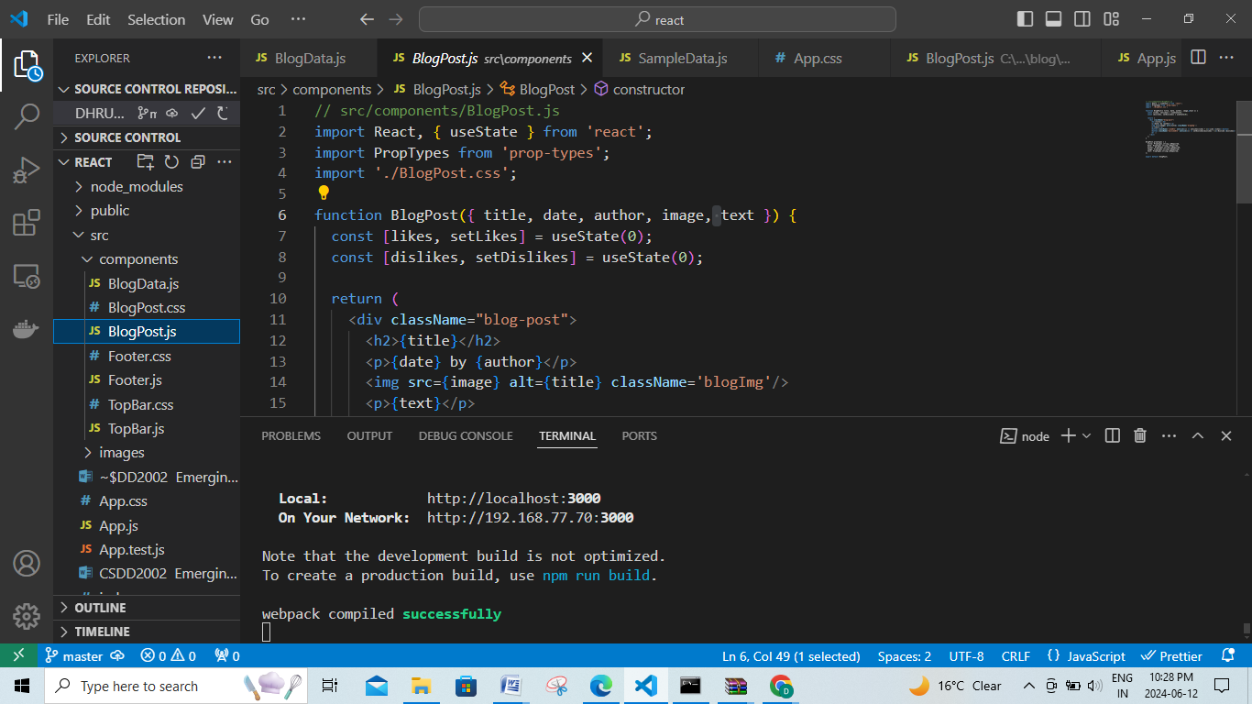

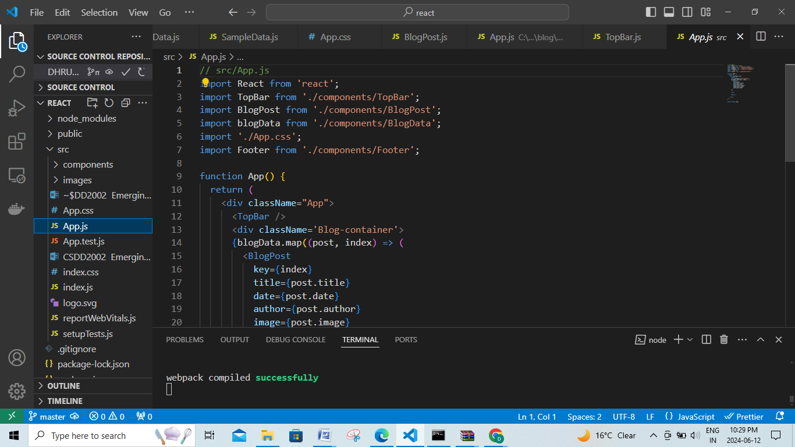

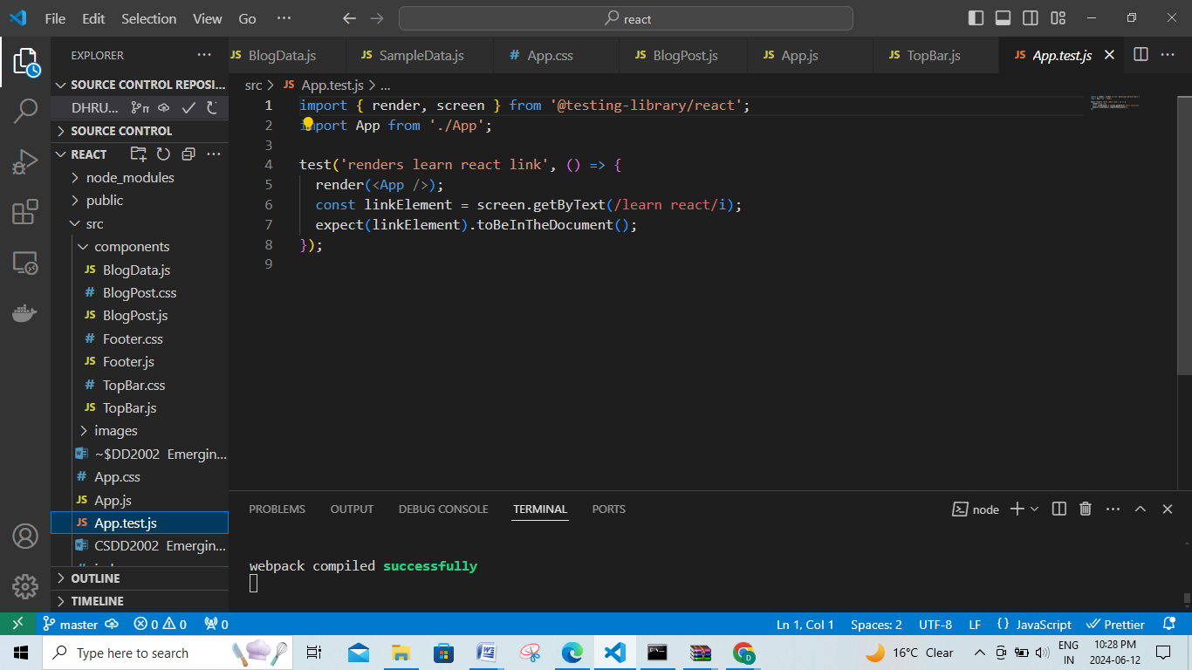

**Output:**

